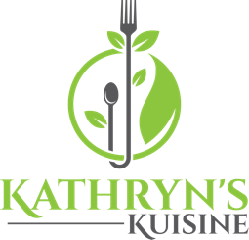

Sunday Virtual Cooking Classes and Wine Pairing
July 11, 2021
Light Crab Cake Sliders w/ Pineapple & Kiwi Salsa
Paired with Sauvignon Blanc

August 1, 2021
Salmon with Soy, Ginger & Sake & Sauté Asparagus & Mushrooms
Paired with Pinot Noir

September 12, 2021
Tuscan Style Buttery Shrimp
Paired with Pinot Grigio

October 3, 2021
Steak au Poivre & Buttered Green Beans
Paired with Cabernet Sauvignon

November 7, 2021
Authentic Chicken Cacciatore
Paired with Sangiovese

December 5, 2021
Braised Chicken w/Asparagus, Peas & Leeks
Paired with Chardonnay
___________________________________________________
All classes will be held on Sundays @ 4:00 PM (PT), 90-minute class sessions, $35 per class
- In each fully interactive class, you will learn about the featured grape varietal, its history, where it grows, taste profiles and how it pairs with wine. I will also guide you through a Sensory Wine Tasting.
- You will also learn hands on step-by-step cooking instructions with the selected entree to enjoy at the end with your wine. All questions are welcome
- Please notify me at least 7 days before class for your attendance at kathrynskuisine@gmail.com.
- (Hint: Use a large enough computer device to see more clearly, ie labtop, IPad)
- Each full interactive class is only $35; please Venmo donation to my Venmo address at @Kathryn-Arceneaux-1 or kathrynskuisine@gmail.com.
- I will send you a Zoom link with an Ingredients & Materials List you will need for the class a week before class and the day before as a reminder
Full recipes will be shared after the class.
- Prior to class, please use the Ingredients & Materials List for ingredients shopping. There will be some prep required so we can jump right in to cooking.
- Seating is limited to 10 students per class in order for all to enjoy and get the most out of learning.

